Steps to run Messaging Service Prototype

1. First, install express, cors, axios dependencies within the backend folder.
2. Express is used due to its lightweight, easy routing and easy routing nature. CORS is used as it also supports other types of HTTP requests unlike JSONP. Axios is used as it has built-in **XSRF (Cross-Site Request Forgery)** protection, also it has ability to **intercept HTTP**requests by default unlike Fetch.
3. Now, run the “npm run start” in the backend folder terminal. This basic server will run on port **3001**, accepts calls from any origin, and has one API endpoint for **/authenticate**.

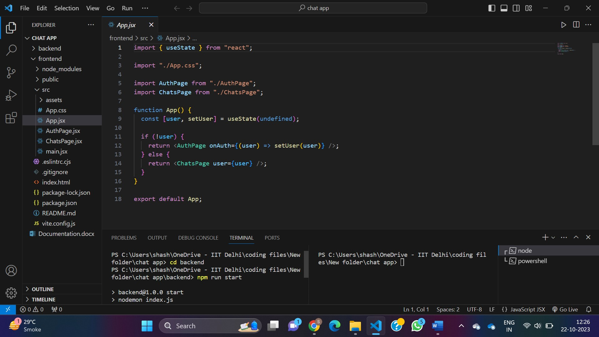

1. Now, come to the frontend folder and type “npm install” in the terminal.
2. Install axios and react-chat-engine-pretty in frontend folder terminal and type “npm run dev” command in terminal.

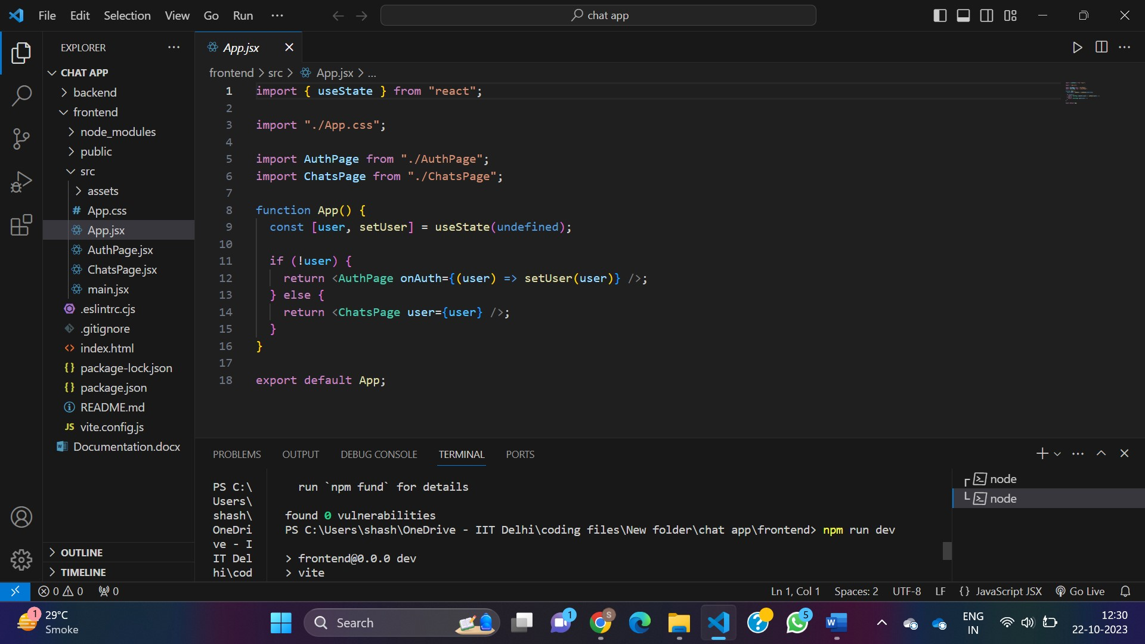

1. Make sure to have two terminal windows, one with backend folder running with “npm run start” command and other one frontend folder running with “npm run dev” command till you are working with the chat.

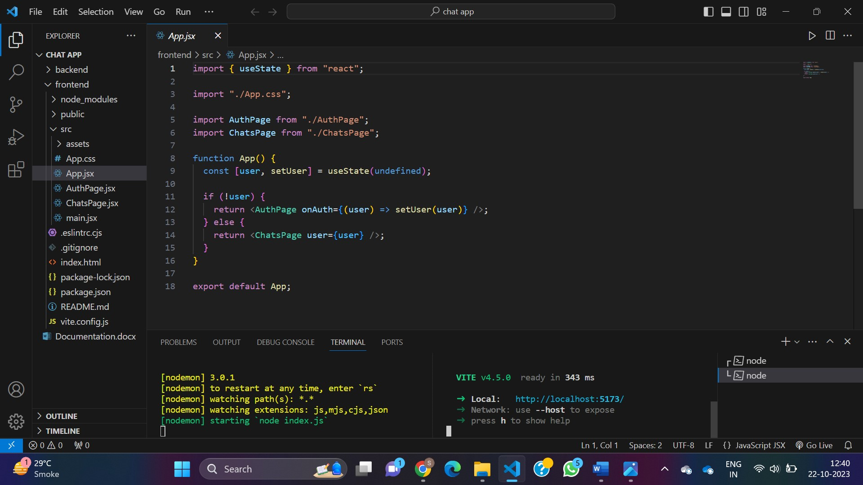

1. Click on the <http://localhost:5173/> link and ready to use the app.

